INDIA’S AGRICULTURAL CROP PRODUCTION ANALYSIS (1997-2021)

SUBMITTED BY

TEAM ID:NM2023TMID30851

TEAM MEMBERS:

1.PRIYADHARSHINI.V(6C29240F0AC8C92ABE34A998F6207A21)

2.PREETHI.R(ADF6BC73911E77EA4A243884EDE92059)

3.PAVITHRA.L(7D8A7FF983850569AA14926328C1DE41)

4.PAVITHRAVANI.V(DF447588FB3F4EB9FEB46E32C30D52D0)



DEPARTMENT OF PHYSICS

L.R.G GOVERNMENT ARTS COLLEGE FOR WOMEN

TIRUPUR -641604

10TH OCTOBER 2023

Project Report Template

**INDIAS AGRICULTURE CROP PRODUCTION ANALYSIS**

1. INTRODUCTION

1.1 Overview

India's agriculture crop production analysis involves evaluating various aspects of crop cultivation, yields, and their impact.

The project involves assessing the quantity of crops grown across the country. Key factors are state wise agricultural land , yield by season , crops, crop plantation by area and more key factors are given the tittle it also plays on important role in international business in import and export activities

**1.2 Purpose**

Farmers and agricultural organizations use crop production analysis to make informed decisions about crop selection, planting schedules, and investment in technology and Inputs to optimize yields. It is used to easily understand the India’s agriculture crop production in state wise . It is used to achieving high growth by raising productivity

**2. Problem Definition & Design Thinking**

2.1 Empathy Map

The empathy map is used to explained the what heard then say and what behaviour have we observed and what their fears, frustrations and finally what their wants and needs

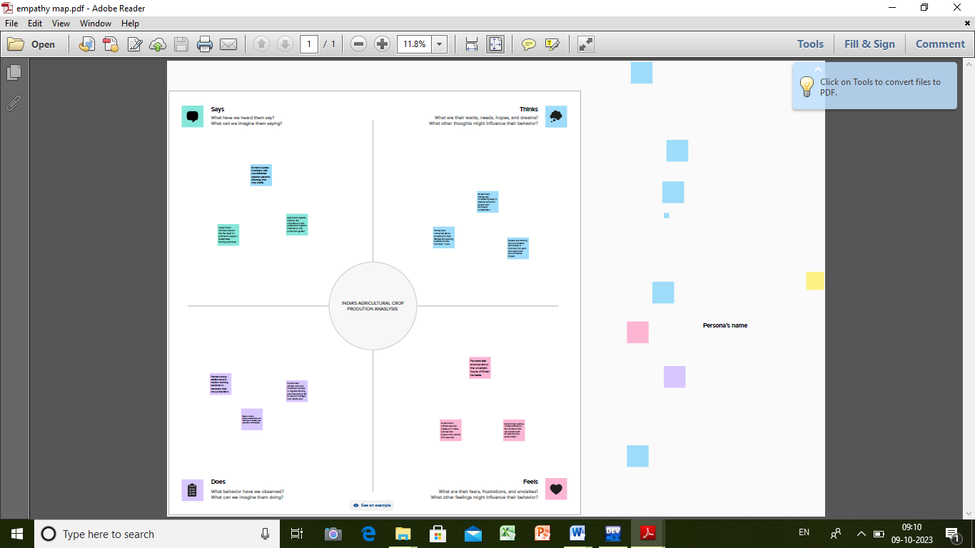

2.2 Ideation & Brainstorming Map

The brainstorming map of our project is explained team gathering, problem and their solutions and also explained group idea of India’s agriculture crop production analysis

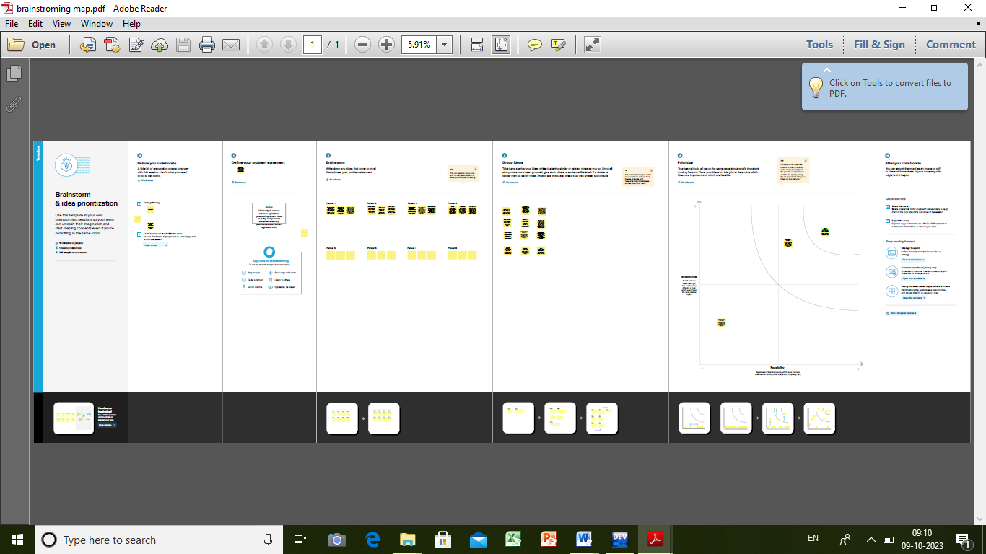

**3. RESULT**

The results of India's agriculture crop production analysis can provide valuable insights and data-driven information that contribute to informed decision-making and policy formulation We Explained Detailed data on the current crop yields for various crops in different regions of India

We can see the final outputs of India’s agriculture crop production analysis

STATE WISE AGRICULTURAL LAND: This Map explore the country wise Agricultural Land .

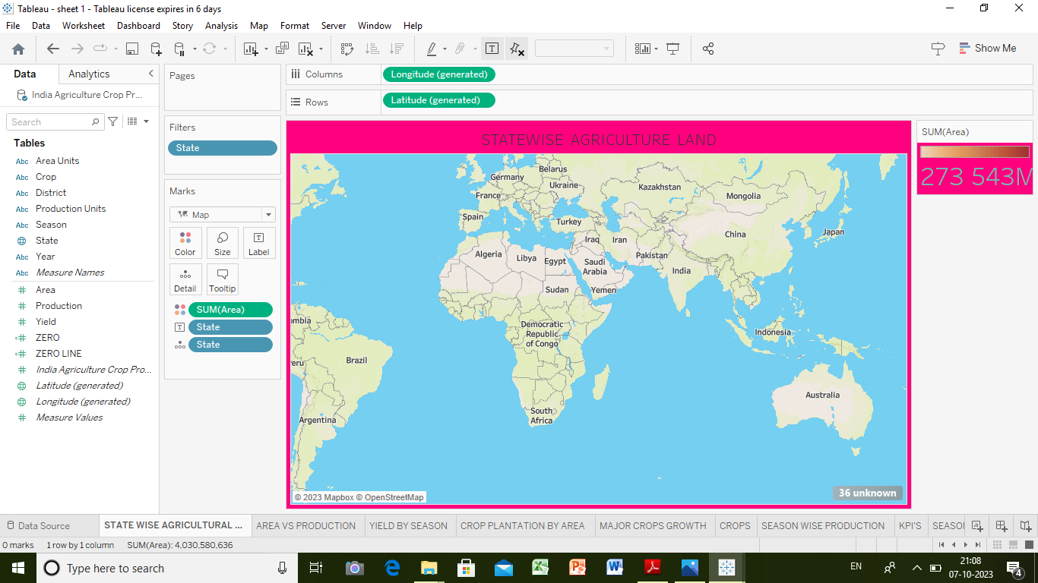

AREA VS PRODUCTION: This data shows the area vs production in agriculture.

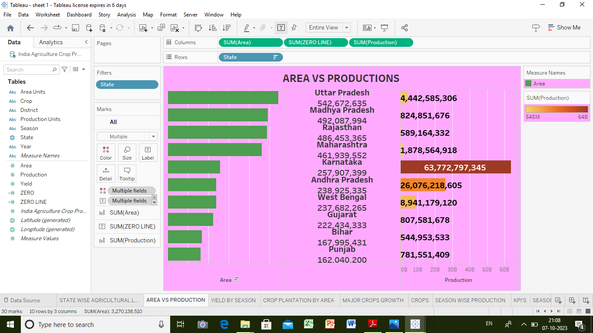

YIELD BY SEASON: Seasonal bounty exploring the variations in agricultural yields

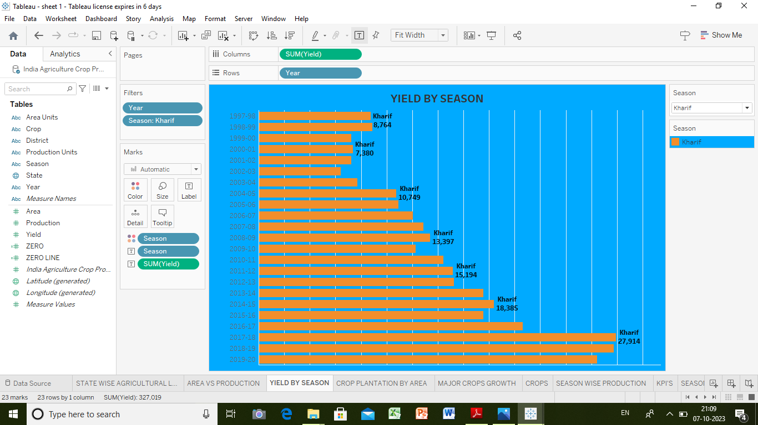

CROP PLANTION BY AREA: Growth in landscapes understanding crop plantation by patterns

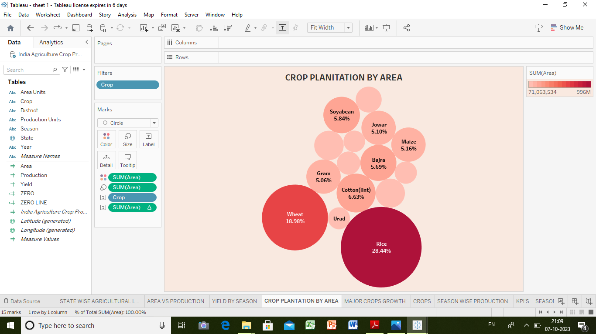

MAJOR CROPS GROWTH: It tracks the growth of major crops

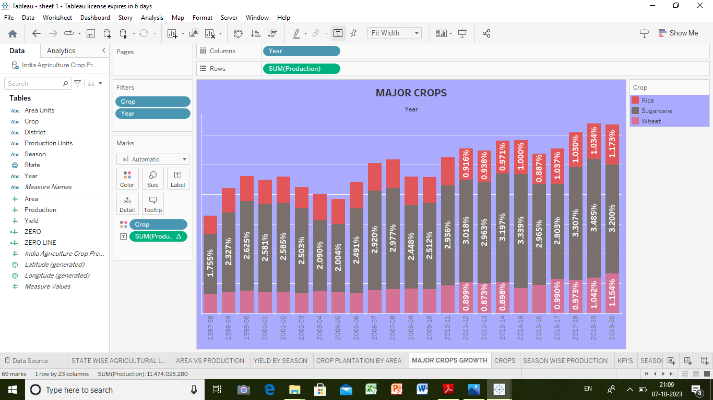

CROPS: Cultivating insights a story of crops

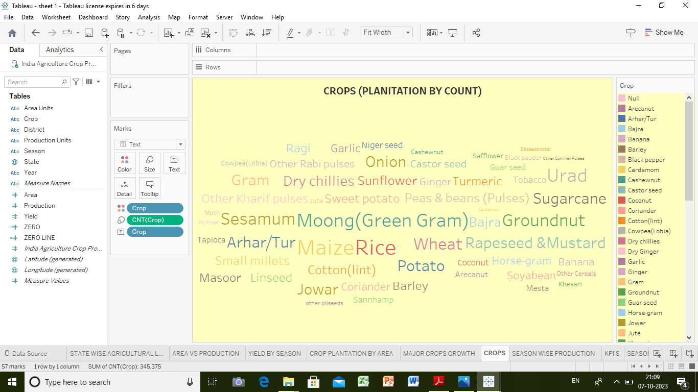

SEASON WISE PRODUCTION: Harvest seasons unveiled - A season-wise production analysis

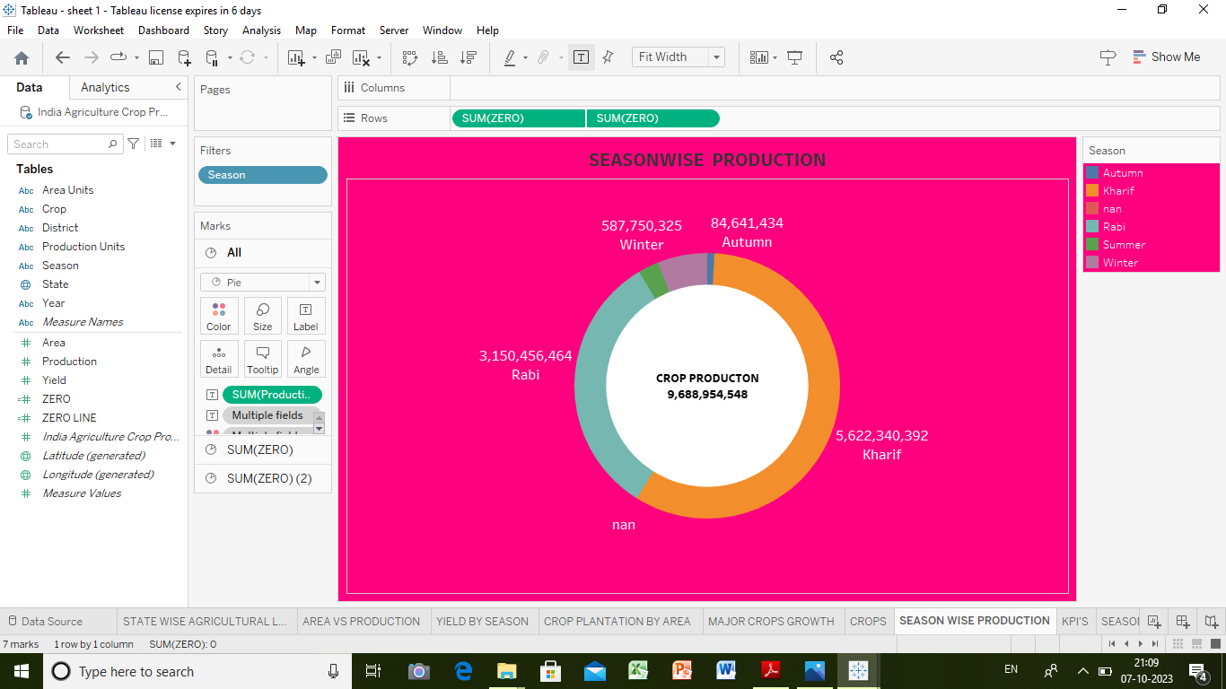

KPI'S : Navigating the world of KPI’S

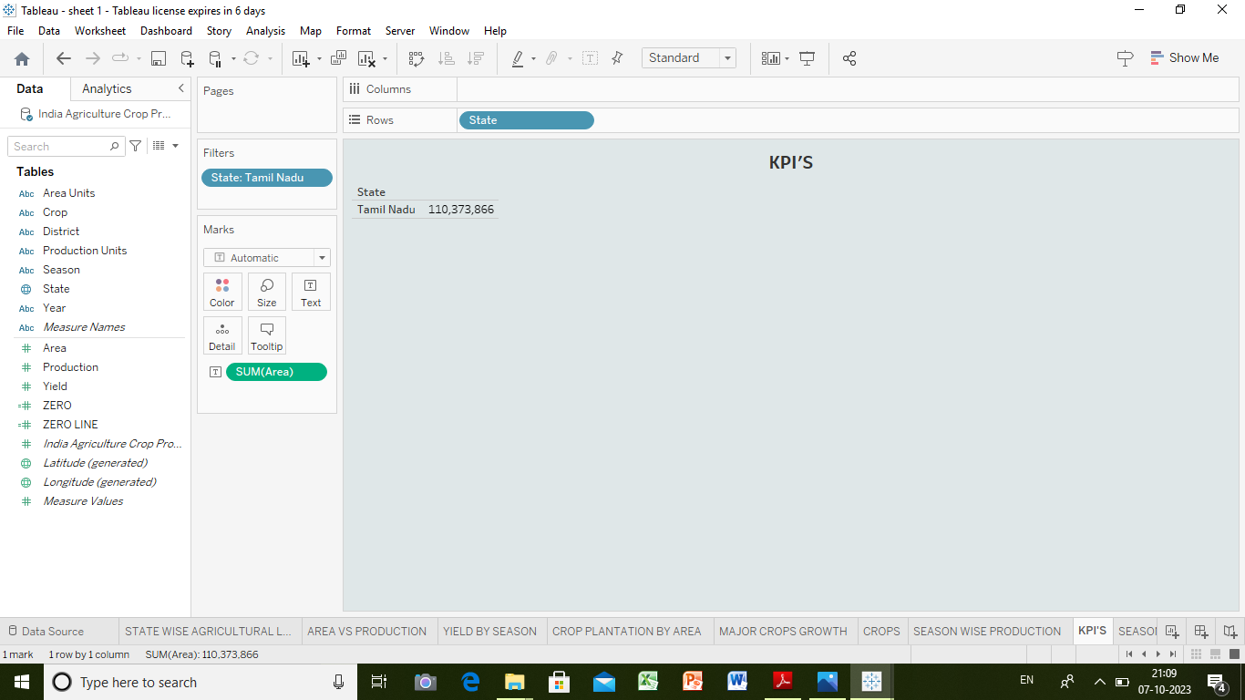

SEASON BASED CULTIVATION: A visual journey through season -based farming

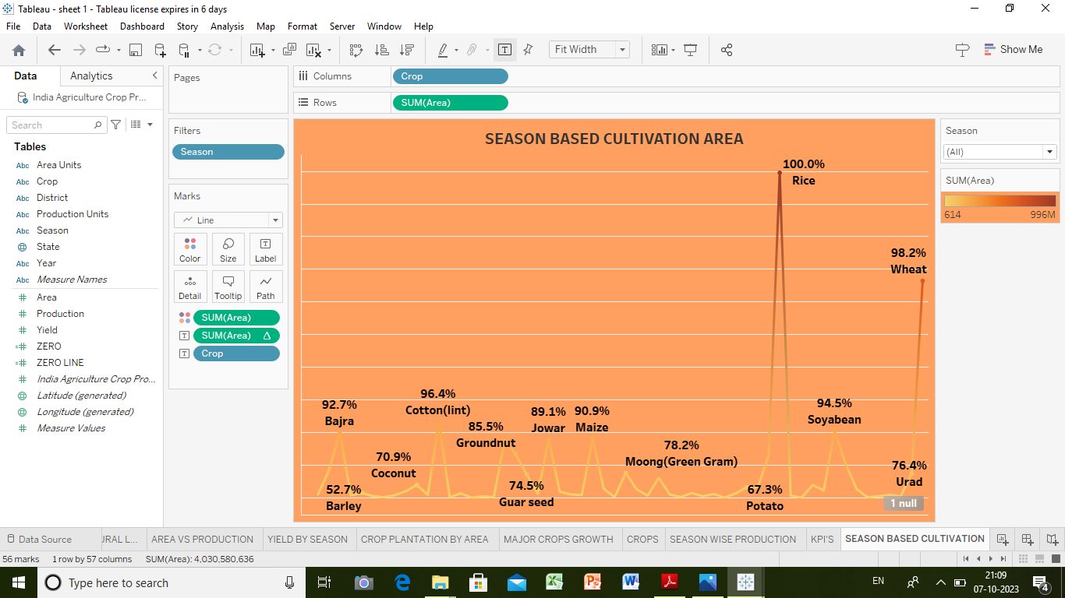

**4. ADVANTAGES & DISADVANTAGES**

**Advantages :**

It is used to explain the overall India’s agriculture crop productions in state by sate.

We can explain the India’s agriculture crop productions in different types of method **Disadvantages :**

**It has limited sources because**  some farmers, particularly smallholders, may have limited access to technology and data, hindering their ability to benefit from analysis insights.

**5. APPLICATIONS**

Farmers can be made to take decisions about crop selections, planting times, and harvesting schedules based on data and forecast.

Crop production data guides research efforts to improve crop varieties and or farming techniques.

Crop productions data is crucial for the food processing industry to plan for raw material procurement and production capacity.

**CONCLUSION**

we have found the easy way to understand the agriculture using different types and models. Some findings are given below.

* state wise agricultural land
* yield by season
* season based cultivation

**FUTURE SCOPE**

As technology continues to advance, there will be a greater emphasis on harnessing big data, artificial intelligence (AI), and machine learning (ML) for more precise and real-time crop production analysis.

Future analysis will focus on developing climate-resilient agricultural practices, including drought-tolerant crop varieties, weather forecasting tools, and adaptive strategies to mitigate the impact of climate change.

The use of technology and data will enhance farmer training and extension services, ensuring that farmers have access to the latest knowledge and best practices.

The future technology is developed to find the India’s agriculture crop production in district level .